Examination rules

To: | Students, study secretaries, lecturers and Heads of programmes at Dania Academy
Prepared by: | Dania Quality & Analysis and Dania Counselling and Internationalisation
To be archived: | Https://eadania.dk/uddannelser/ with link to Moodle and Dania Intra
Publication date: | 16 March 2020 based on merging of several local publications
Latest revision: | 23 March 2020
The examination rules describe the rules and regulations in connection with holding exams at Dania Academy
Subject to any printing errors and changes

Contents
1. Examination rules 4
2. General examination rules 4
2.1 Aids 4
2.2 Examination language 5
2.3 Exams on special conditions 5
2.4 Plagiarism—use of own and others' work 5
2.4.1 Plagiarism control 6
2.4.2 Procedure in the event of copying and plagiarism 6
2.4.3 Reuse of assignments 6
2.5 Irregularities, incorrect behaviour / violation of rules 6
2.6 Complaint about the exam 7
2.7 Participation in exams 7
2.7.1 Withdrawal from exams 7
2.8 Time of exams 8
2.8.1 Late attendance 8
2.8.2 Time for the commencement of the exam 9
2.9 Exam forms 9
2.10 Illness and make-up exams, re-exams and new exams 9
2.10.1 Illness 9
2.11 Grading of and publicity at the exam 10
2.11.1 Co-examiner's task 10
2.12 Exam results 11
2.13 Maximum period of study 11
3. Rules for written exams 11
3.1 Food, drink and smoking 11
3.2 Rules for the use of PCs for written exams 11
3.2.1 Submission via WISEflow 12
3.2.2 Knowledge of software programs 12
3.2.3 Upload to WISEflow 12
3.2.4 Electricity, etc. 12
3.2.5 Breakdown when submitting via WISEflow 12
3.2.6 Conditions for the use of supplementary equipment at exams 12
4. Rules for the completion of written exams 13
5. Especially for online examination - oral 13
6. Exams abroad 14
7. Especially for 14
7.1 Technical programmes 14
7.1.1 Written exam with physical presence at the Academy - Scanning of handwritten assignments and submission via WISEflow 14
7.2 Mercantile programmes 16
7.3 Social science programmes 16
7.4 IT programmes 16
7.5 Public health programmes 16

1. Examination rules
Dania Academy holds exams to assess whether and to what extent the student's qualifications are in accordance with the description of knowledge, skills and competencies set out in the programme curriculum.

These examination rules contain the general guidelines for conducting examinations at Dania Academy.

The students are assumed to have familiarised themselves with the rules before taking part in exams. It is
the responsibility of the student to familiarise themselves with and observe the examination rules of the Academy.

The examination rules have been prepared in accordance with the current guidelines of the Ministerial Order on Examinations on Professionally Oriented Higher Education Programmes - called the Examination Order - under the Ministry of Education and Research.

The current ministerial order can be found at www.retsinfo.dk.
The above ministerial order specifies the minimum guidelines for the examination rules. Reference is also made to the description of exams in the individual programme curriculum.

The curriculum distinguishes between two different examination forms—external and internal. The difference is that an external exam is with an external co-examiner.

Students must bring their ID for all examinations and present it on request.

2. General examination rules
2.1 Aids
It appears from the curriculum for the individual programme element which aids students are permitted to bring to exams.

If the student makes use of aids that are not allowed during the exam, it will result in expulsion from the exam.

Unless explicitly stated in the examination paper, the student will NOT have access to the Internet during the exam.

In the case of written exams, cell phones and other communication equipment must be switched off and handed over to the invigilators before the exam begins.

Students must bring the allowed aids themselves as well as pens, pencils and possibly a calculator. Students
are not allowed to share aids or lend their aids to fellow-students during an exam. The Academy will not lend aids to students during the exam.

The invigilator has the right at any time to check the aids that a student has brought along.
If there is suspicion of unauthorised communication at exams with access to the Internet, the Academy reserves the right to take out a number of the electronic media used at the exam immediately upon completion of the exam.

At the written exam, the student must take all the permitted aids out of their bags before the exam begins. The invigilators will tell the students where to keep their school bags and any plastic bags.
Students are not allowed to communicate with each other once the exam has begun. To address an invigilator, the student must raise their hand.

If a student attempts to get in touch with a fellow student, the student will immediately be
expelled from the exam.

2.2 Examination language
If a programme is taught in Danish, the exam will also take place in Danish, unless part of the purpose of the individual exam is to document students’ foreign language skills. The exam may be conducted in Swedish or Norwegian instead of Danish, unless the purpose of the exam is to document the student's skills in Danish.

Where programmes or single subjects are taught in English or another foreign language, the exams will be conducted in this language unless part of the purpose of the individual exam is to document the students’ skills in another language.

If possible, the Academy may allow that a student takes an exam in a foreign language unless the purpose of the exam is to document the student’s skills in Danish.

If a student would like to take an exam in another language, a written application must be sent to
the study administration no later than two months before the exam is to be held. There has to be some very good reasons for wanting to change the examination language.

2.3 Exams on special conditions
Special exam conditions may be agreed for students with physical or mental disabilities or similar difficulties, where this is necessary to put them on an equal footing with the other students in the same exam situation.

It is a condition that this does not change the academic level of the exam.

The provision of special exam conditions is decided by the programme on the basis of a specific assessment.
An application for special exam conditions must be in writing and submitted to the study administration no later than 14 days before the exam is held. Documentation of disability must be enclosed to the application.

Students with a permanent disability who are already receiving assistance through Special Educational Support will have been informed about how to apply for special exam conditions as part of the SES course.

2.4 Plagiarism—use of own and others' work
When writing an assignment, students may wish to make use of their own previously assessed assignments or that of others as part of their documentation, be it quotes, graphic presentations, tables, literature, texts from the Internet, people's opinions or an adapted version of other people's work, from a textbook, for instance.

In this case, the source MUST always be clearly stated.

Quotations (direct copying) may only be used to a limited extent, and only a small portion of the work of others, say, a couple of lines or so where this is necessary in order to understand the context.

When quoting, remember to:

- use quotation marks
- write the title of the book and the name of the author
- indicate the specific page reference

Direct copying without a clear source reference will be perceived as "cheating" - plagiarism. In such cases,
the paper will be rejected, and the student will be expelled from the exam.

2.4.1 Plagiarism control
To ensure proper use of source material, other people's work, etc. the Academy makes use of the program URKUND. URKUND is able to detect copying and scans papers for plagiarism from the web and from the system's own database as well as from previously submitted assignments, including the student's own assignments.

When exam papers / exam projects are automatically uploaded to URKUND via
WISEflow, the Academy and the lecturer in question will receive a detailed report indicating a percentage of copying, as well as a detailed overview of which section has been copied and from where.

Submission of papers via WISEflow will appear from the individual curriculum or instruction in connection
with the exam.

2.4.2 Procedure in the event of copying and plagiarism
The assessors assess the individual assignment. Upon discovering a high degree of plagiarism, insufficient quoting or reuse, the written material will be rejected, and the student will be expelled from the exam.

Notification of expulsion:

- At oral exams: in the actual room where the exam is held, and a letter is sent via e-Boks.
- At written exams: by letter via e-Boks.

Expulsion from an exam due to cheating means that the awarded grade, if any, will be annulled, and the student will have used one exam attempt.

In connection with rejection of exam papers and projects, the student is entitled to file a complaint in accordance with the general examination rules.

Please refer to the Ministerial Order on Examinations on Professionally Oriented Higher Education Programmes - Part 10 of the Examination Order.

If a student complains about a rejection of an exam paper, the student can request a copy of the URKUND report.

2.4.3 Reuse of assignments
In connection with the submission of exam papers and projects, students are not allowed to re-use previously assessed assignments.

If a student wants to reuse previously assessed assignments, these must be referenced in the same way as other sources.

2.5 Irregularities, incorrect behaviour / violation of rules
If, during an exam, a student obtains or gives a fellow student wrongful assistance in answering a paper or uses unauthorised aids, they will immediately be expelled from the exam.
If, during or in connection with an exam, a student is presumed to have wrongfully
obtained or given assistance to a fellow-student, to have presented the work of another as their own or made use of previously assessed work without making use of refences, they will be expelled from the exam.

Furthermore, the student will be expelled from the programme for a shorter or longer period. In such
cases, the student will get a warning that if such behaviour is repeated, they will be expelled for good.

If a student exhibits disruptive behaviour in connection with an exam, e.g. by not observing
the instructions of the invigilators, they will be expelled from the exam.

If a student leaves the examination room without the permission of the invigilator, the examination has been interrupted and cannot be continued.

At written exams, the student must not leave the room until they have submitted their paper.

2.6 Complaint about the exam
A complaint about circumstances of an exam must be submitted in writing to the Academy, and it must be well-argued.

The complaint must be filed no later than two weeks after the assessment or the expulsion or rejection of the paper has been communicated in the usual way.

In accordance with the ministerial order on examinations, the complaint may relate to:
- The basis of the exam, including exam questions, assignments and similar, and its relation to the objectives and requirements of the programme,
- the course of the exam or
- the assessment

Reference is also made to www.retsinfo.dk, as well as the Ministry of Education and Research's website.
The complaint procedure can be found at www.eadania.dk

The study-start exam is not covered by the rules in Part 10, Complaints about exams, cf. the Ministerial Order on Examinations on Professionally Oriented Higher Education Programmes - Part 3.

For further information, including information about what information a complaint should contain, please refer to the student counsellors or the local study secretary.

2.7 Participation in exams
All students are automatically registered for exams when the attendance requirement has been fulfilled, and assignments / projects, etc. have been submitted.
Non-participation in an exam means that the student will have used one examination attempt. This does not apply, however, if the student was unable to attend due to documented illness. The student is entitled to three examination attempts for each exam.

2.7.1 Withdrawal from exams
The following rules apply unless otherwise stated in the curriculum. Withdrawal from a written exam: 7 days before the day of the exam.
Withdrawal from an oral exam which includes the submission of an assignment: 7 days before the deadline for submitting the assignment. Withdrawal from exams which include the submission of a written assignment or project for assessment: 7 days before the deadline for submitting the assignment.
Withdrawal from the final exam projects: 14 days before the deadline for submission of the project.

If, due to exceptional circumstances, the student would like to withdraw from the exam after the fixed deadline, they may apply for an exemption to be made. An exemption will be made if the exceptional circumstances can be documented. The withdrawal must be emailed to the relevant programme secretary at the academy. The withdrawal is valid when the student receives a confirmation. The study administration will then register the student for the upcoming examination in the subject area, and the exam will not count as an exam attempt.

The student is entitled to 3 exam attempts. Excluded from this is the study-start exam, where students only have two attempts, cf. Ministerial Order on Examinations on Professionally Oriented Higher Education Programmes - Part 3 of the Examination Order.

The curriculum may lay down rules for terminating enrollment if a student has not passed any exams over a continuous period of at least one year.

For more information, see the section on study activity in the curriculum for the programme in question,
including the requirements for active student participation and submission of assignments, projects, etc.

2.8 Time of exams
It appears from the individual curriculum and activity plan of the individual programme when the exams of the semester take place.
The student must consult these to always keep up to date. However, if there is a change later than 14 days before the exam, information will be sent to the students’ email addresses.

The exact exam time will be announced by the student administration no later than one week before the exam is held.

The student must show up at least 30 minutes before the exam is scheduled to begin on the fixed date.

Students will have access to the room 15 minutes before the exam is set to begin.

2.8.1 Late attendance
For written exams, the door to the room will close at the beginning of the exam. If a student arrives too late, the student is referred to the study administration.

At the oral exams, a student is considered as absent if not present at the scheduled time for the exam. If a student arrives too late, the student is referred to the study administration.

A student who arrives too late for an exam can only take the exam if the Academy considers the delay to be reasonably accounted for and documented and on the condition that the student in question is unlikely to have obtained any information about the exam.

Only if the circumstances are exceptional will the exam time be extended.

2.8.2 Time for the commencement of the exam
A written exam will have begun when the examinee has been made aware of or has had the opportunity to familiarise themselves with the basis of the examination.

An oral exam will have begun when the student has entered the examination room.

2.9 Exam forms
The exact exam forms appear from the curriculum. Any formal requirements for the exam/paper will also appear from the curriculum.

In individual as well as group exams, the performance of the individual student will be assessed.

Part-exams that have not been passed cannot be re-taken if they form part of an overall exam that has been passed unless otherwise stipulated in the ministerial order or the curriculum for the programme.

2.10 Illness and make-up exams, re-exams and new exams
The student has three attempts to pass an exam.
The student may apply for an exemption from this rule in exceptional circumstances such as death or serious illness in the immediate family.

A passed exam cannot be re-taken. A part-exam that has not been passed cannot be re-taken if the overall exam has been passed, cf. the exam form in the curriculum.

A student will have used an exam attempt if they do not show up for an exam that they have registered for, of if they are expelled during the exam.

Make-up exams and re-exams are held for students who are entitled to it in accordance with the provisions.

Students are entitled to a re-exam if they have failed a scheduled exam.

Students are entitled to a make-up exam if, due to documented illness at the time of the ordinary exam, they have not been able to participate in a scheduled exam.

A new exam is an extraordinary exam caused by the Academy having found errors and omissions in the exam paper and where such shortcomings have been remedied by way of a new examination.
A student may also be entitled to a new examination following a decision on a complaint about an exam.

When a student has used all their exam attempts, the person(s) in charge at the Academy will terminate the student's enrollment.

2.10.1 Illness
If, due to illness, a student is unable to take part in an exam, the study administration must be notified immediately.

In case of illness, the student must obtain medical documentation which must be presented to the Academy no later than three weekdays after the exam was held. In this case, the exam will not count as an exam attempt. The student will have to pay for the medical documentation.

If the illness occurs during the actual exam, one of the invigilators must be notified, and the student will then leave the room.
The student must present the Academy with medical documentation of the illness that occurred during the exam within 3 working days after the exam. In this case, participation in the exam will not count as an exam attempt. The student will have to pay for the medical certificate.
A sick exam is held as soon as possible after the student is back at school.

The second and third exam attempts will be held as soon as possible and, as far as possible, at the latest when the exam in question is scheduled to be held again, possibly as a make-up exam.
If the exam is in the final examination term of the programme, the student must have the opportunity
to take the exam in the same examination term or in immediate continuation of it.

For a new exam attempt in an exam involving a project or product, a product must be submitted which has not yet been assessed.

The Academy may grant the individual student an exemption from the times set for passing the exam or exams due to reasons of maternity or in case of exceptional circumstances.

2.11 Grading of and publicity at the exam
The oral exams are generally open to the public.

However, the Academy may restrict access to the premises due to a lack of space, and spectators may be denied access or be expelled where this is necessary to ensure peace and quiet at the exam. In the interest of the student, the Academy may derogate from the rule that oral exams be open to the public.

In the case of clinical exams, permission to keep the exam open must be given by the patient.

Only the examiner(s) and the co-examiner(s) may be present during the deliberation of oral exams (including the oral defence of projects, etc.) However, the Academy may decide that future examiners may attend the deliberation.

The examinee has the right to be informed of their grade and what it was based on without the participation of other examinees or spectators.

Any type of recording before, during and after the exam is not allowed.

If the examinee brings a bag or similar to an oral exam, they must remember to take it along when they leave the room when the oral examination is over, and it must not be present in the room during the deliberation.

2.11.1 Co-examiner's task
The co-examiner must:
- ensure that the exams are in accordance with the objectives and other requirements laid down in ministerial orders, or in accordance with the ministerial orders

- assist in and ensure that the exams are carried out in accordance with the applicable rules; and

- contribute to and ensure that students receive a fair and just treatment, and that their performance is reliably assessed in accordance with the rules on grading and other rules for the programme.
(2) The co-examiner and examiner must take notes on the performance and grading, which may form part of an opinion in a possible complaint case. The notes must be kept for 1 year.
(3) The activities of the co-examiners are covered by the provisions of the Public Administration Act on Inability and Confidentiality.

2.12 Exam results
Rules for written exams
It appears from the exam plan which has been handed out when, at the latest, the student will be informed of the result of the exam. If, in special cases, the Academy is not able to meet the deadline, the student will be informed of a new deadline. The result is published via WISEflow and not via telephone or mail.

Oral exams:
The exam result is communicated to the student immediately following the exam.

All exams must be passed. Passed exams cannot be retaken.

In the event of a failed exam, the student is automatically registered for a new one unless otherwise agreed.

2.13 Maximum period of study
Programmes with a standard duration up to and including 150 ECTS points must be completed within a number of years corresponding to twice the standard period of study. Programmes of 180 ECTS points must be completed at the latest within the standard period of study plus two years. The remaining programmes must be completed within six years.

This does not include leave.

Exams that the student must take before the end of the first year of study must be passed before the end of
their second year of study.

Enrollment in the programme is terminated for students who have not passed any exams in a continuous period of at least one year.

3. Rules for written exams
3.1 Food, drink and smoking
Food and drinks are allowed.

3.2 Rules for the use of PCs for written exams
Students must use their own PC for the written exams.

For students who are to sit a written exam and use their own PCs, there are a number of rules to be aware of.

3.2.1 Submission via WISEflow
Written exam paper must be uploaded to WISEflow. Before the exam begins, the student must ensure that the PC is compatible with WISEflow and that the username and password for the program work.

The exam paper must be uploaded to WISEflow before the end of the exam.

If a student wants to enclose handwritten appendices for assessment, the cover sheet (3 sheets) must be filled in, and the invigilator then signs for them.

3.2.2 Knowledge of software programs
No help is offered on the use of programs during exams. The student must therefore be familiar with the insertion of headers, conversion, merging of files, etc. before the exam begins. Furthermore, students must be familiar with the conversion of Word and Excel files to PDF format.

The student must be aware of which file formats they are allowed to use.

3.2.3 Upload to WISEflow
The actual paper MUST be submitted in PDF in WISEflow, since the submission folder does not recognise other formats.

However, it is possible to upload extra material in other formats, e.g. Word or Excel files.

It is the student's responsibility to ensure that a pdf converter is installed on their own PC. The IT department does not provide any technical assistance.

3.2.4 Electricity, etc.
When using their own PC, it is the student's responsibility to ensure that the PC and installed programs function. The Academy cannot be held responsible for crashes, software or hardware defects.

During the exam, it will be possible to plug in a laptop. Students must bring their own power supply and battery for their PCs. The student must bring an extension cord.

The Academy cannot be held responsible for the student's operating errors (lack of knowledge of the program) and other unforeseen events such as power failure, machine breakdown, etc. In such cases, what is left of the exam will be conducted manually.

3.2.5 Breakdown when submitting via WISEflow
If a crash occurs so that the paper cannot be uploaded to WISEflow, the students will be provided with an email address to which a pdf file with the exam paper must be sent. Students may not leave their desks until the exam paper has been received and registered by the invigilator.

3.2.6 Conditions for the use of supplementary equipment at exams
During written exams students are allowed to bring and use their own headset, but only if the sound level does not bother the other students. Music must not be live streamed over the internet but must be downloaded to the computer before the exam begins. The use of services such as Spotify, Yousee, Tidal, etc. is not allowed, neither online nor offline.

4. Rules for the completion of written exams
When the exam is over, no one should rise until the invigilators have verified that the assignments have been saved on WISEflow and all exam papers, appendices, assignments and drafts have been collected. Only then will the students be given permission to leave the room.

Students are allowed to submit their assignments before time. For the sake of other students, students are not allowed to leave the room during the last 15 minutes of the exam. This also includes toilet visits.

If the exam paper is submitted before time, a student is not allowed to stay immediately outside the exam rooms. This is to avoid disturbing noise.

Students must remain seated until the invigilator has picked up their assignment and made sure that it has been uploaded to WISEflow. When a student submits their paper, they must confirm that the assignment has been uploaded correctly to the relevant folder before leaving the room.

It is the sole responsibility of the student to ensure that everything they would like to be assessed has been correctly uploaded and submitted to the invigilator.

The name and class number must, as a minimum, appear from the front page. There must be page numbers on all material / pages (on both fair copy and draft) submitted for assessment.

If a student would like a draft to be assessed, this must be explicitly communicated to the invigilator. The following will then be added to the cover sheet:
"Draft enclosed for assessment".

Any draft that is not to be assessed must be submitted separately.

5. Especially for online examination - oral
NB: Special rules apply during the Corona crisis, where the ministry dispenses with the requirement for the presence of invigilators at oral online exams, cf. letter sent to the students, examiners and co-examiners.

The student (the examinee) finds a suitable exam place/room with a stable internet connection, where they can sit undisturbed during the exam.

The student must find their own invigilator— a person, fellow student, friend or colleague who can confirm that everything is in accordance with the rules for the exam.

The invigilator must be of legal age and be able to speak and understand Danish. For examinations in English, the invigilator must be of legal age and be able to speak and understand English. The invigilator must confirm the identity of the examinee, be present and visible throughout the examination and confirm that the exam is conducted in accordance with the Danish examination rules.

The invigilator must be registered and verified by the administration before the exam is conducted.

The student must show a photo ID to the invigilator before the exam begins.

Any additional expenses associated with the online exam will be borne by the student.

Upon prior agreement with the examiner, an oral examination scheduled to take place at the academy may instead be conducted as an online examination.

The agreement must be in writing (via mail) and the following must be fulfilled:

- A link to the online exam room must be available for, say, a week before the exam so that it can be tested.
- the student is familiar with the format and can use e.g. Moodle, Skype for screen sharing, etc.
- the student has had an opportunity to test the format and is familiar with it.
- the student has tested sound and image in good time, so that there is time to remedy any problems

6. Exams abroad
Oral exams may be held online, cf. section 5, and written examinations may be held at a Danish representation or elsewhere abroad, the reason being that the student is unable to attend the scheduled exams in Denmark for practical or financial reasons and on the condition that the student and Dania agree to this.

The Academy may charge the student in whole or in part for the expenses the Academy has held in connection with the exam. It is a condition that the student has stated in writing in advance that they are willing to pay the expenses in question based on an estimation by the institution of the expected amount.
The Academy can make it a condition that the full amount should be paid before the exam can be held.

7. Especially for
7.1 Technical programmes

7.1.1 Written exam with physical presence at the Academy - Scanning of handwritten assignments and submission via WISEflow
Students must submit their assignments digitally.

Procedure:
- When the exam is over, the students hand in the cover sheet with the handwritten assignments to
the invigilator.
- The students remain seated until everyone has scanned their assignments. One by one, the students will scan their papers.
- The students send them to themselves and upload them to WISEflow.
- As pointed out - the students remain seated until everyone has handed in in WISEflow.

Invigilation must be extended by one hour, the same goes for the time limit for submission in WISEflow.

Submission in WISEflow:
- Upload your digital solutions DO NOT PRESS SUBMIT YET!

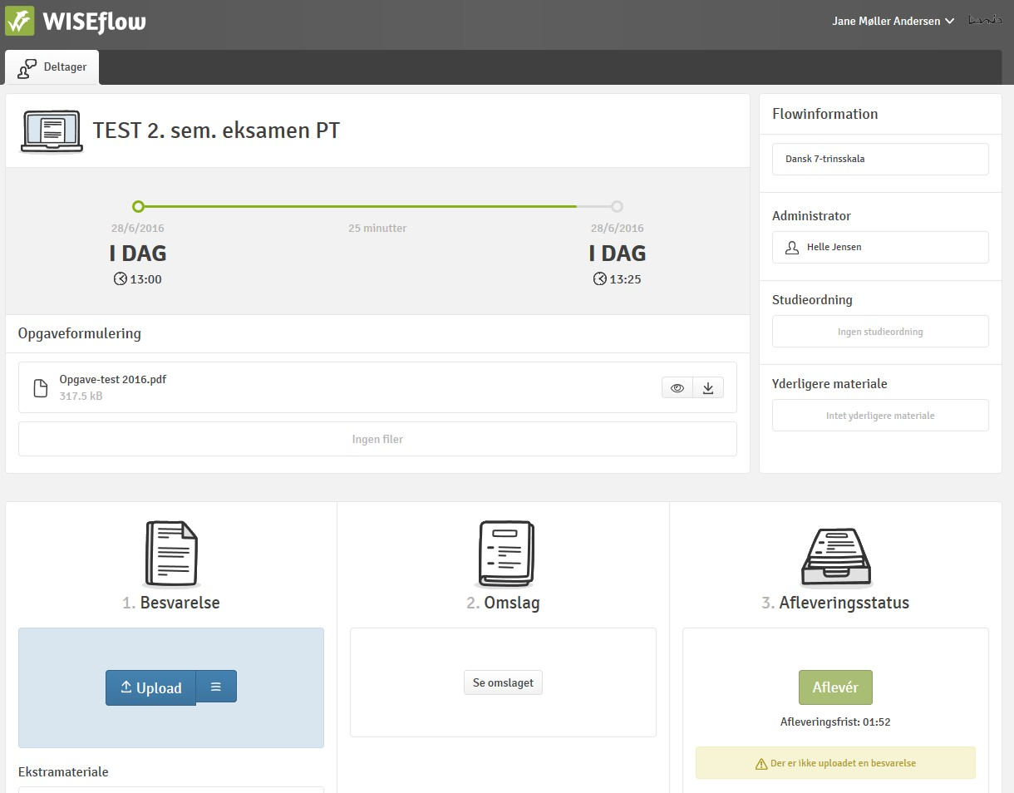

- Paper versions must be scanned in and uploaded as extra material

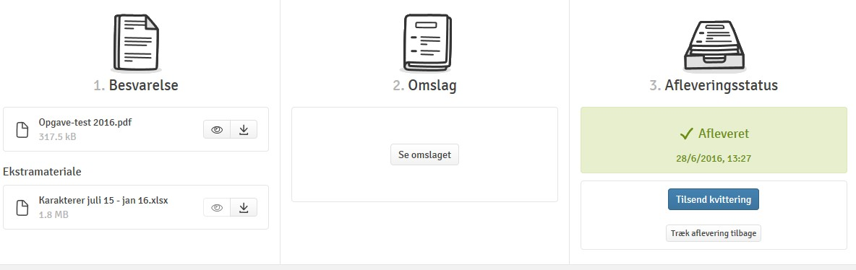

- The scanned appendices are uploaded as “Extra material”

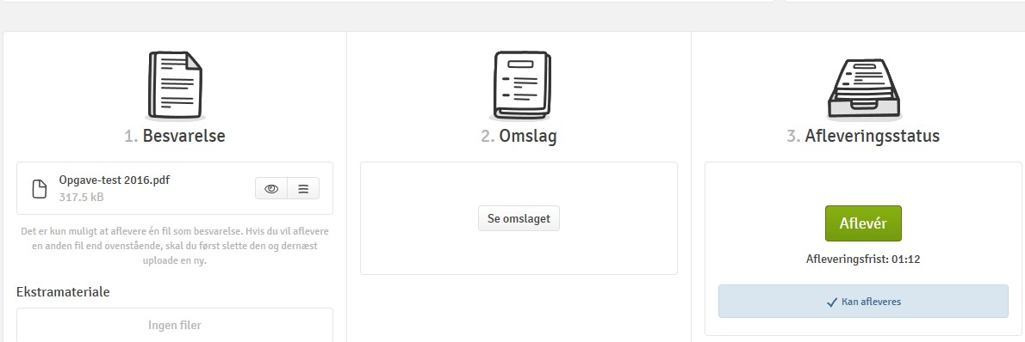

- Press Submit when everything has been uploaded

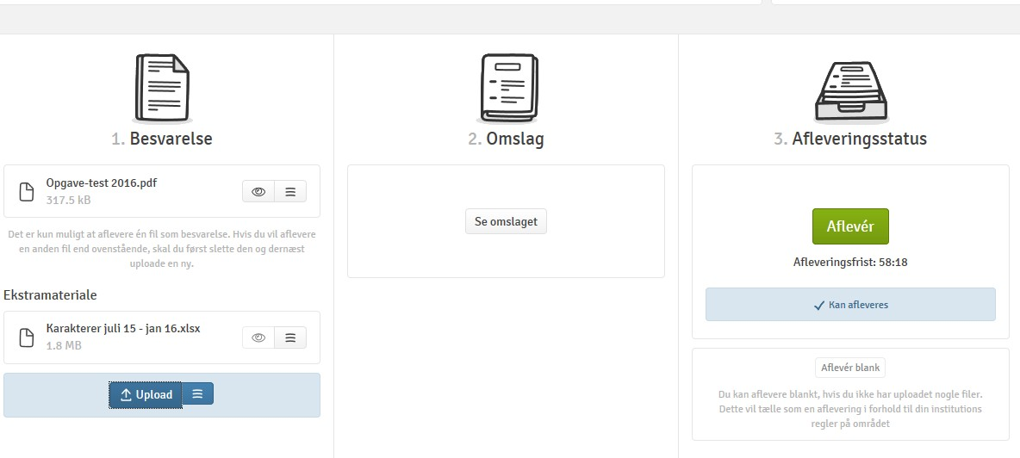

7.2 Mercantile programmes
No additions

7.3 Social science programmes
No additions

7.4 IT programmes
No additions

7.5 Public health programmes
SPECIFICALLY FOR 2.7.1 THE NATIONAL CURRICULUM FOR OPTOMETRY DOES NOT ALLOW STUDENTS TO WITHDRAW FROM EXAMS.

Change log:

Version | Date | Performed by | Description
1 | May 2018 |  | The examination rules describe the rules and procedures for holding exams at Dania Academy
2 | 04-10-2018 |  | A section on exam forms has been added, including the possibility of individual oral examination in a final assignment prepared in a group, cf. ministerial order on amendment to ministerial order on examinations on professionally oriented higher education programmes, Ministerial Order no. 1502 of 28/11/2017.
3 | September - 2019 | Dania Quality and Analysis and Dania counselling and Internationalisation in collaboration with study secretaries and student counsellors. | Adapted Ministerial Order no. 1500 of 02/12/2016 with subsequent amendments and Ministerial Order no. 841 of 24/06/2018.
4 | 16.03.2020 | Dania Quality and Analysis and Dania counselling and Internationalisation in collaboration with study secretaries and student counsellors. | See additions and changes in the accompanying covering letter.
5 | 23.03.2020 | Dania Quality & Analysis, Proof-reading, Management / CHAB | 23.03 20 Deadline for the Leadership Hearing, which has resulted in the following changes which have been added to the covering letter:  Section 2.2. The deadline for applying for the use of another language is changed from three to two months.  Section 2.10. Changed to: The second and third exam attempts will be held as soon as possible and, as far as possible, at the latest when the exam in question is scheduled to be held again, possibly as a sick exam.  Section 5. Headline clarified with the addition of "oral". Reference to appendix with special conditions regarding Corona crisis.  Section 6. Text clarifying that these are oral online exams and reference to section 5.  Section 7.5 was added: Especially for 2.7.1. The national curriculum for optometry does not allow students to withdraw from exams.

Exceptional circumstances will typically be something external and unpredictable, something that is outside of students’ control, and something they have not been able to plan around or take into consideration.
Delays in public transport, crashes, etc. are not considered reasonable grounds.
Exceptional circumstances will typically be something external and unpredictable, something that is outside of students’ control, and something they have not been able to plan around or take into consideration.
Students may bring a desktop or a laptop to the exam. Either way, the student must arrange for their own setup.

